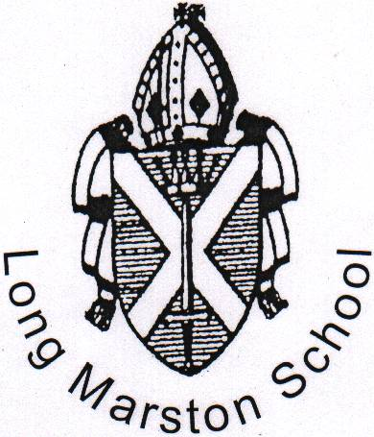 |  | LONG MARSTON VA C of E PRIMARY SCHOOL  STATION ROAD  LONG MARSTON  HERTFORDSHIRE  HP23 4QS  Tel: 01296 668386  Fax: 01296 660412
Headteacher: Mrs L Whateley BSc Hon NPQH |  | admin@longmarston.herts.sch.uk  www.longmarston.herts.sch.uk

10th March 2023

Dear Parents/Carers
Infant and Junior Milk

Milk is provided for infant and junior children. If you wish for your child to have milk during the Summer Term the cost will be £22.94 to be paid in advance.

There will be no charge for:

- Reception children in the period before they turn 5.
- Children receiving Free School Meals (benefit related) if they require milk.

We regret there are no refunds for absences and an order is for a term’s duration.

Milk is offered free for all children under 5. The decision has been made to now offer you the option of receiving free milk up to the date of your child's 5th Birthday rather than charging you for the whole term in which they turn 5.

Please confirm your milk requirements by completing the following jotform (https://form.jotform.com/223353121096953) by Thursday 23rd March 2023. We will then add any invoice requirements for payment to Arbor to be paid by Monday 27th March 2023.

Yours sincerely

Mrs L. Whateley
Headteacher

