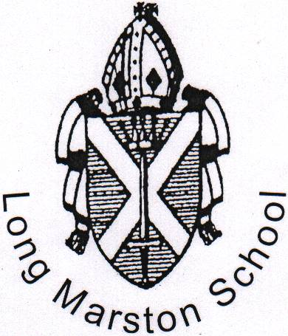 |  | LONG MARSTON VA C of E PRIMARY SCHOOL  STATION ROAD  LONG MARSTON  HERTFORDSHIRE  HP23 4QS  Tel: 01296 668386  Fax: 01296 660412
Headteacher: Mrs L Whateley  BSc Hons NPQH |  | admin@longmarston.herts.sch.uk  www.longmarston.herts.sch.uk

March 2023

Dear Parents

KS2 Pupil Premium

Since April 2015, all schools, preschools, childminders and other childcare providers have been able to claim extra funding through the Early Years Pupil Premium to support children’s development, learning and care. I am writing to families to explain what the Early Years Pupil Premium is, explain who is eligible for this funding and, importantly, to ask you to complete the attached application form so that if your child is eligible we can claim the extra funding to help them to learn well and be successful.

The Pupil Premium provides up to an extra £302 a year for us to help each eligible three and four year old child who is taking up the full 15 hour a week place in a nursery class, preschool or with a childminder or other child care provider.

This extra money is to support those children whose parents are in receipt of certain benefits, those who are in local authority care and any who left care because they were adopted or were subject to a special guardianship or child arrangements order. This additional money could make a significant difference to children.

We can choose to use the extra funding in whatever way will best improve the quality of the early year’s education that we provide for your child. This could include, for example, special equipment or additional specialist help with early speech and communication.

It is recognised that high quality early education can influence how well a child does later at both primary and secondary school so we do want to make the most of this additional funding. You may be aware if you have older children that a pupil premium has been available for school age children and it has proved to have given a real boost to the children receiving the funding. We want to do the same for our early years children entitled to this funding.

Therefore, we ask that all parents / guardians complete the online form so that we can check whether your child is eligible. This will allow us to claim the additional Pupil Premium for as many children as possible to help us provide high quality learning opportunities, which will benefit all the children.

Please complete the form online using the following link and inform the school as soon as you have completed this.

Your child can get a free school meal if you receive any of the following:
- Income Support
- Income-based Jobseekers Allowance
- Income-related Employment and Support Allowance
- Support under Part VI of the Immigration and Asylum Act 1999
- The guaranteed element of State Pension Credit
- Child Tax Credit (as long as you’re not also entitled to Working Tax Credit and you don't get more than £16,190 a year)
- Working Tax Credit run-on (paid for 4 weeks after you stop qualifying for Working Tax Credit)
- Universal Credit (with annual earned income of no more than £7,400 after tax and not including any benefits you get).
Apply today if you receive any of these benefits. It takes 5 mins and in most cases we can tell you straightaway if your child can get free meals at school.
Children in year 3 or older might be entitled to extra help.
https://www.hertfordshire.gov.uk/ufs/HCWH.eb?ebd=0&ebz=1_1678460104538

If you have any questions, please contact the School Office.

Yours sincerely

Mrs L Whateley
Headteacher

